1. Create simple web api project from the clear page.
2. Add health checks nuget
3. 
4. Add health checks simple, random, google ping
5. Add AppMetrics nugets
6. 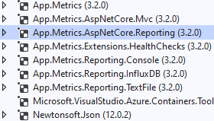
7. Change Startup with adding metrics support and reporting and publishing to influxdb
   1. Copy past and comment
8. Add docker support
9. Add orchestration support
10. Comment docker-compose
11. Login into Grafana
12. Add data source
13. Explore metrics
14. Add simple health panel